

C0653 Start Shop Order Numbering - Deliverynotesaddedcopy.Docm

Customisation Specifications

This document has been approved by

Steve Hardy | Sharon Standing
Business consultant | Solution owner or accountable role
Date | Date

TABLE OF CONTENTS
1.1 Description 6
1.2 Sub Function 7
1.2.1 Functional Requirement and Prerequisites 7
1.2.2 Functional Solution 7
1.3 Change log for revision XX 12

Document Revision History
Revision | Date | Author | Remarks
1 | 12/04/2021 | S. Hardy | 1st draft

Purpose and Guideance
This document specifies how the defined functions shall be developed or how the application shall be customized to solve the business requirements.

The Solution Description defines what will be delivered. The solution is matched against the requirements described in the Requirements section.
The Delimitations describe what is explicitly not covered by this customization. Together with the Solution description, these sections delimit the extent of the functional addition agreed for implementation.

Open Issues/Decisions Required
This specification cannot be completed until the following issues/decisions have been resolved:
Issue/Decision | Responsible
Start Shop Order number stack at 100000 to comply with current systems numbering sequences | S. Standing

Business Requirements and References
Business requirements, references, sources and relations to other customizations are defined in Business requirement specification:
Document No | Rev | Document Name | Comments
?

Solution Description

Description
Shop orders require to use a number series that is 6 numeric characters long. The number needs to start at 100000 at Go Live.

Sub Function

Functional Requirement and Prerequisites
Functional Requirements
The functional requirement is to start the Shop Order numbering Series at 100000 at Go Live.
Pre-requisites
None

Functional Solution
The functional solution is to start the Shop Order numbering Series at 100000 at Go Live.

Configuration

Update the sequence number for SO_ORDER_NO as shown in the screenshot below:

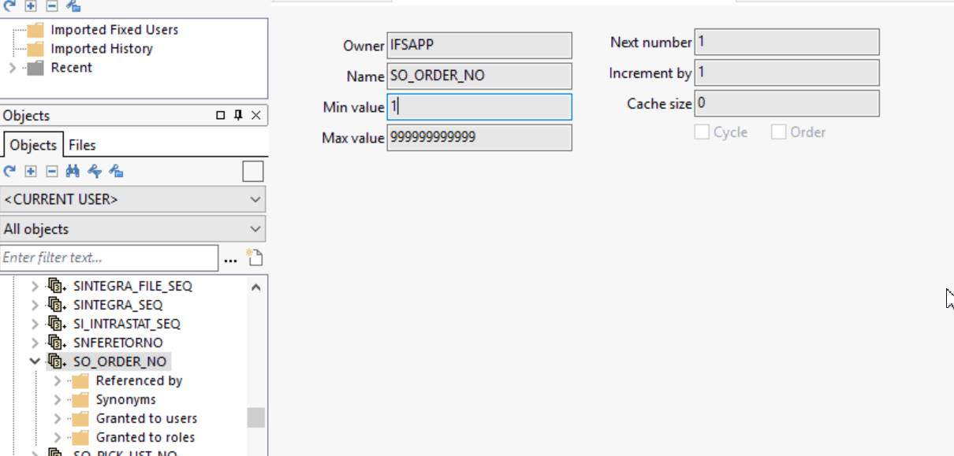

Delimitations

The configuration in this specification will be developed explicitly as written. Requests for changes in the configuration necessary to fulfil (or prepare for future fulfilment of) any requirements not explicitly described in the specification, will be considered outside the scope of this configuration.
Translations other than stated under chapter translations are not included in the scope for this specification.
Changes or extensions on Online Help (F1 Help), e-learning material or process models are excluded from this specification.

Translations
N/A
Prog Text | Translation | Window/form (optional) | Comment

Go Live Information/Upgrade Issues
N/A

Performance Considerations
N/A

Glossary/Acronyms
Commonly used IFS terms within this specification include:
Term | Explanation
LOV | List of Values. This refers to a source list of records from which to select in a form.
RMB | Right Mouse Button. Commonly used abbreviation

Change log, change requests

Change log for revision XX

Change # | Chapter | Description of the change
1
2
3
n | 3.2 | <New column Z added to existing window>

Detailed description of Change #1

Detailed description of Change #n

Technical Implementation
- Deploy the below cdb file after the main installation.
shpord\source\shpord\database\C_EA_ShopOrder_Numbering.cdb

